**Exercise 4: Online Bookstore - Processing Request Body and Form Data**

Business Scenario:

Create endpoints to accept and process JSON request bodies and form data for customer registrations.

1. **Request Body:**

* I implemented a POST endpoint to create a new customer by accepting a JSON request body.

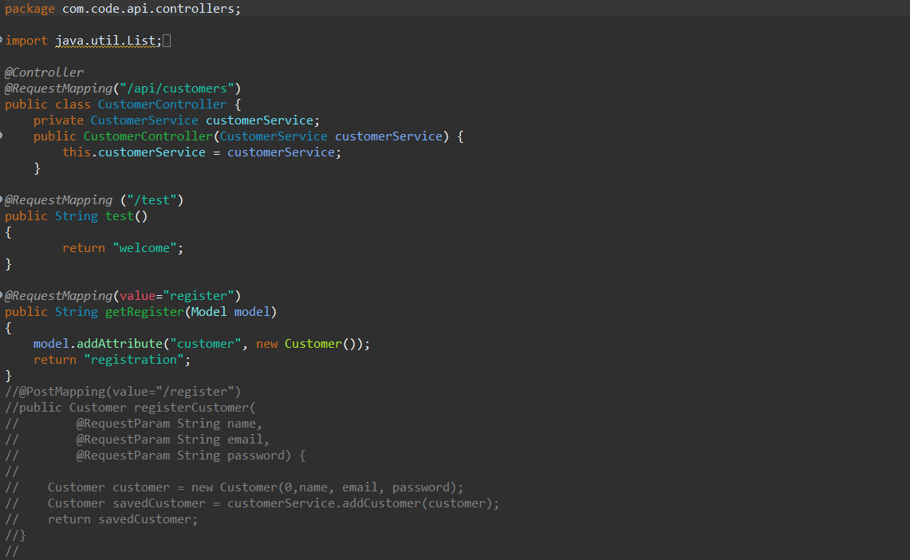

1. **Form Data:**

* I implemented an endpoint to process form data for customer registrations.

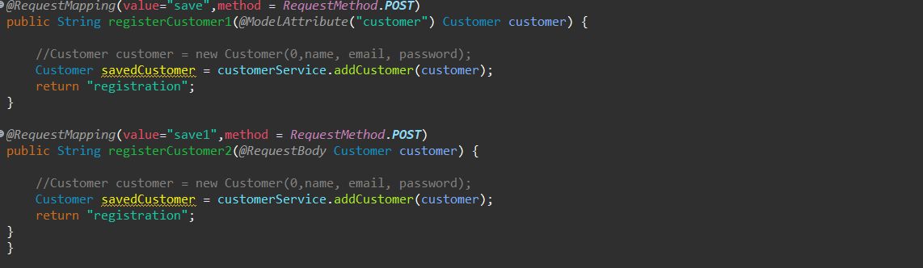

**Output:**

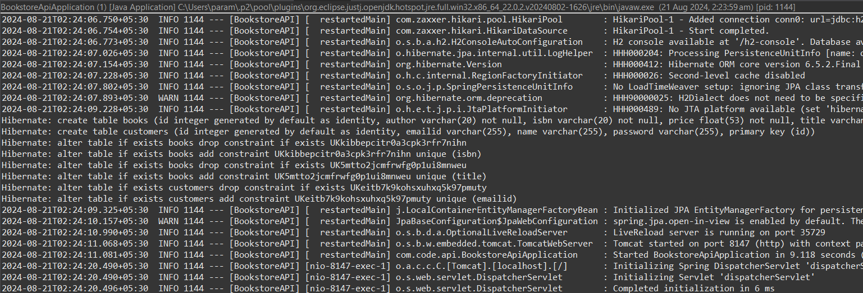

Opening Chrome and typing the url: <http://localhost:8147/api/customers/test>

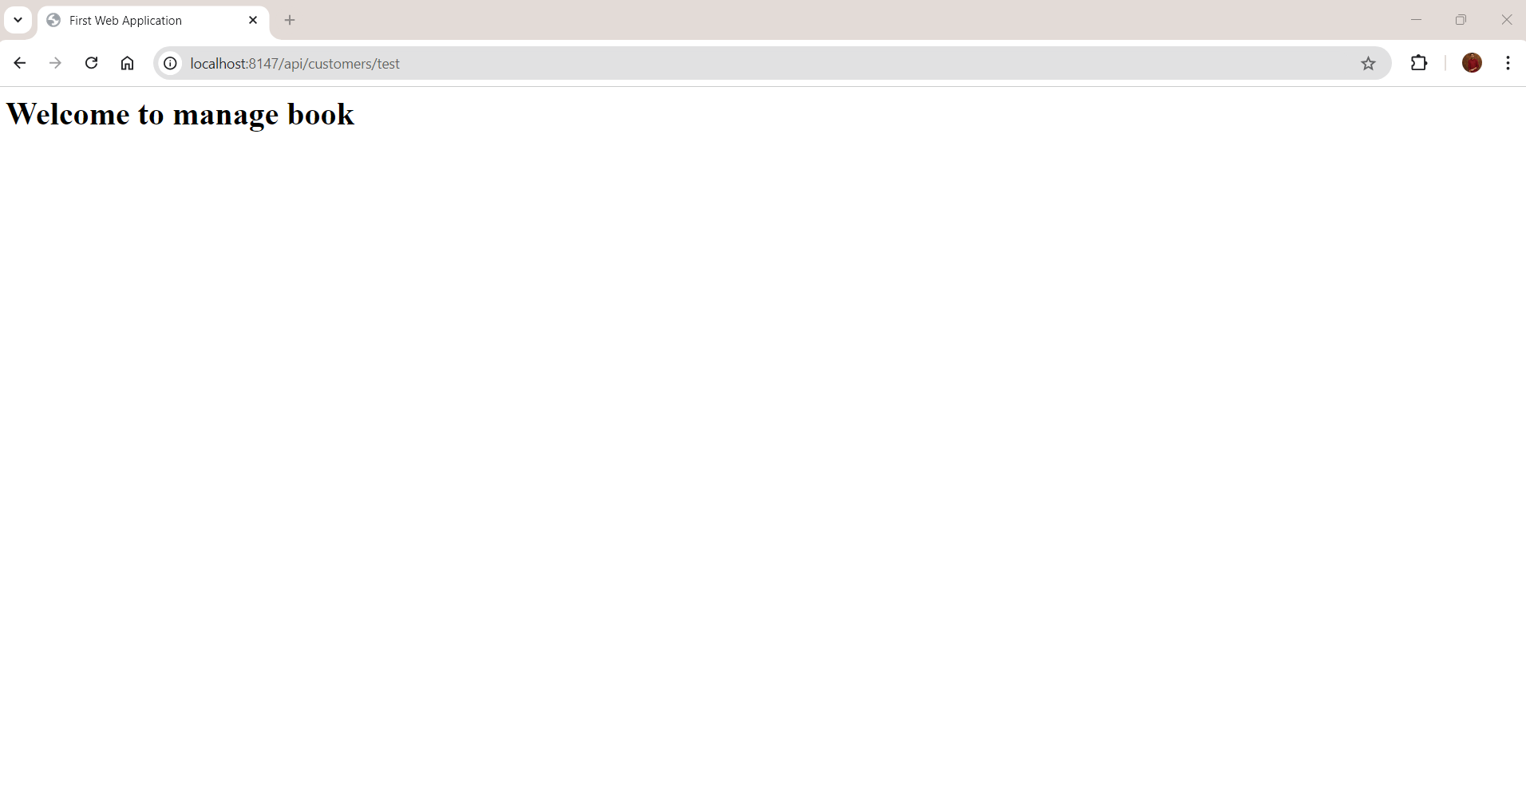

Next registering a new customer by entering the url: http://localhost:8147/api/customers/register

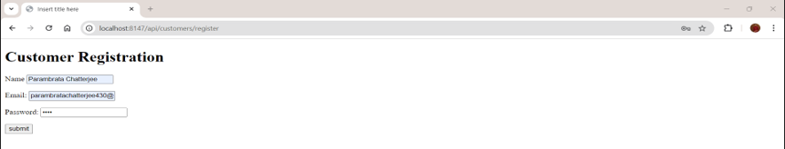

After clicking on submit it gets save as:

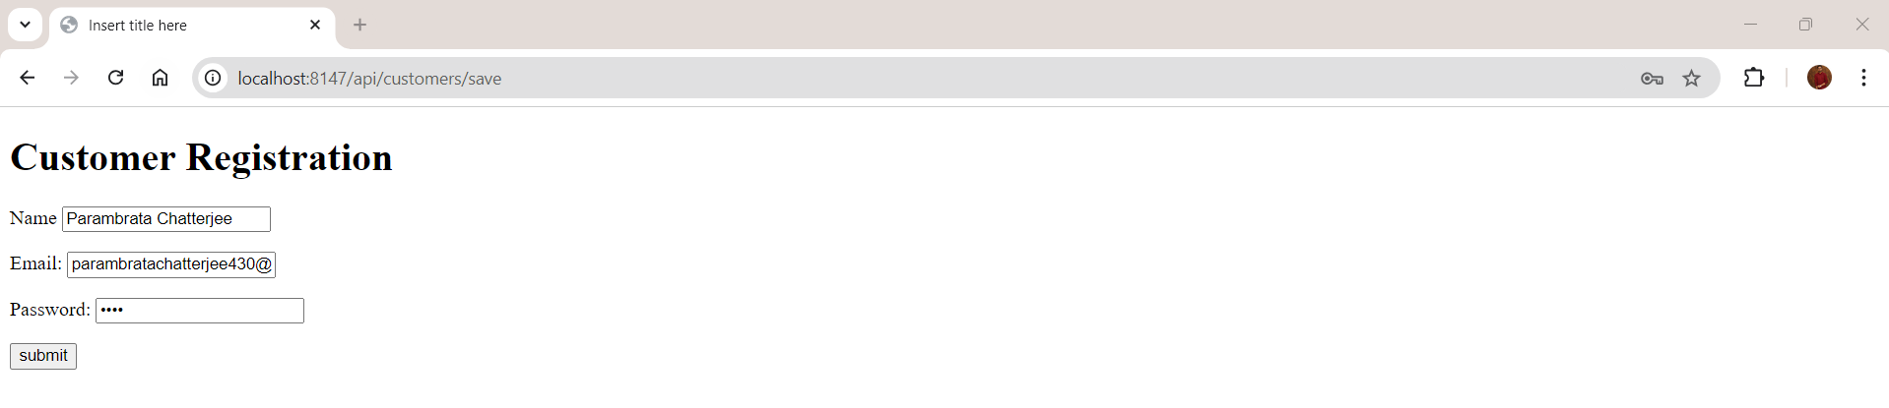

In the IDE the following output is displayed after the operations:

